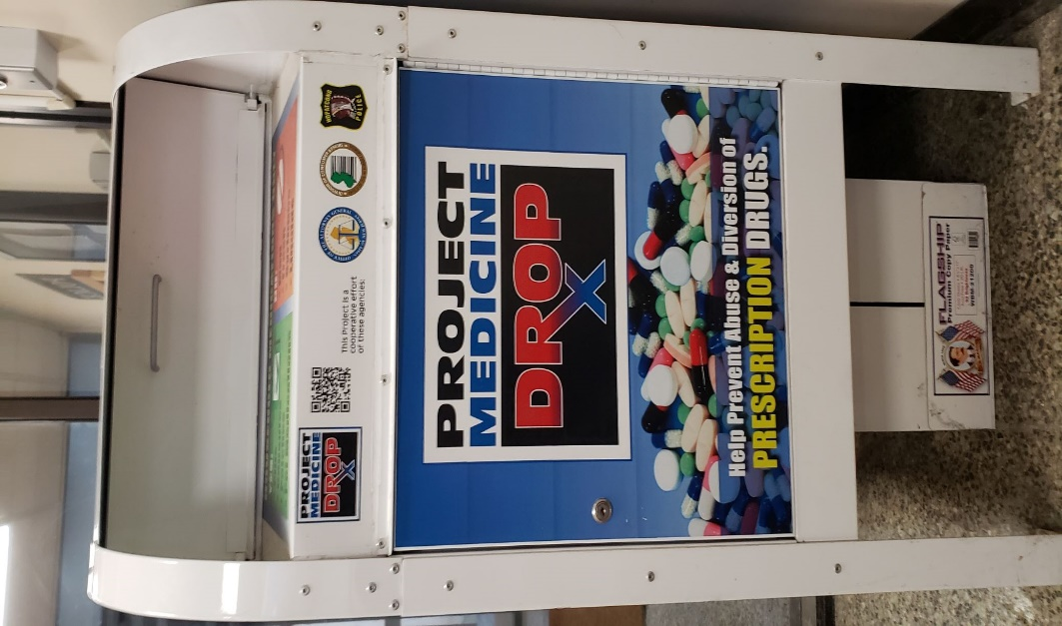
Safely and anonymously dispose of expired or unwanted
prescription drugs utilizing Hopatcong’s PRESCRIPTION
DROP BOX located in the vestibule of the Hopatcong Police
Station, 111 River Styx Rd, Hopatcong, NJ 07843. Drop off
is available to both residents and non-residents 24 hrs/day,
7 days/week for medications only -- no needles or inhalers.

Link to national program: https://www.drugs.com/article/medication-disposal.html

