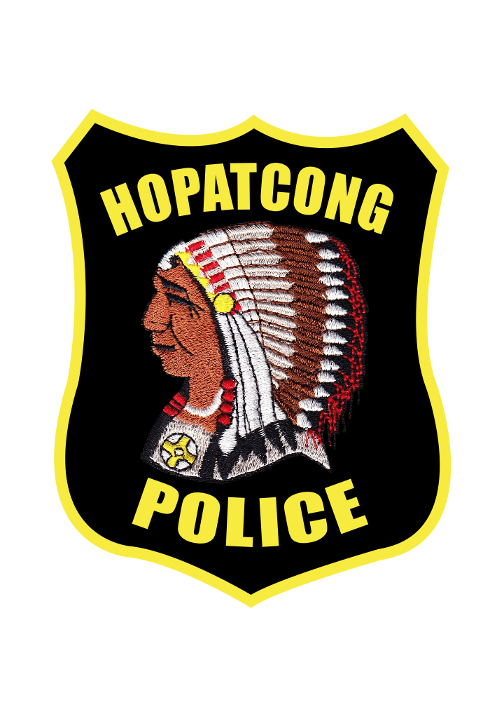
Hopatcong Police Department
Meghan McCluskey
Acting Chief of Police
111 River Styx Road
Hopatcong, NJ 07843
P 973.398.5000
F 973-398-4048

Press Release

January 31st, 2021

Pursuant to Attorney General’s Directive 2021-6, the revised June 2021 Internal Affairs Policies and Procedures (“IAPP”) at Section 9.11.2 requires agencies to publish on their website a synopsis of information regarding officers who receive major discipline—defined as termination, reduction in rank or grade, and/or suspension of more than five days; including the names of the officers sanctioned. This report must also be submitted to the Attorney General and to the County Prosecutor.

From January 1st, 2021 through December 31st, 2021, the Hopatcong Borough Police Department reports that no major disciplinary actions were sanctioned.

